EXP NO 6: DEMONSTRATE VIRTUALIZATION BY INSTALLING TYPE-2 HYPERVISOR IN YOUR DEVICE, CREATE AND CONFIGURE VM IMAGE WITH A HOST OPERATING SYSTEM (EITHER WINDOWS/LINUX).
AIM: To demonstrate virtualization by installing type-2 hypervisor in your device, create and configure VM image with a host operating system (either windows/linux).

PROCEDURE:
STEP 1:Dowload VMware workstation and installed as type 2 hypervisor.
STEP2:Dowload ubuntu or tiny OS as iso image file.
STEP 3: In VMware workstation->create new VM.
STEP 4: Do the basic configuration settings.
STEP 5: Created tiny OS virtual machine.
STEP 6: Launch the VM.
IMPLEMENTATION:
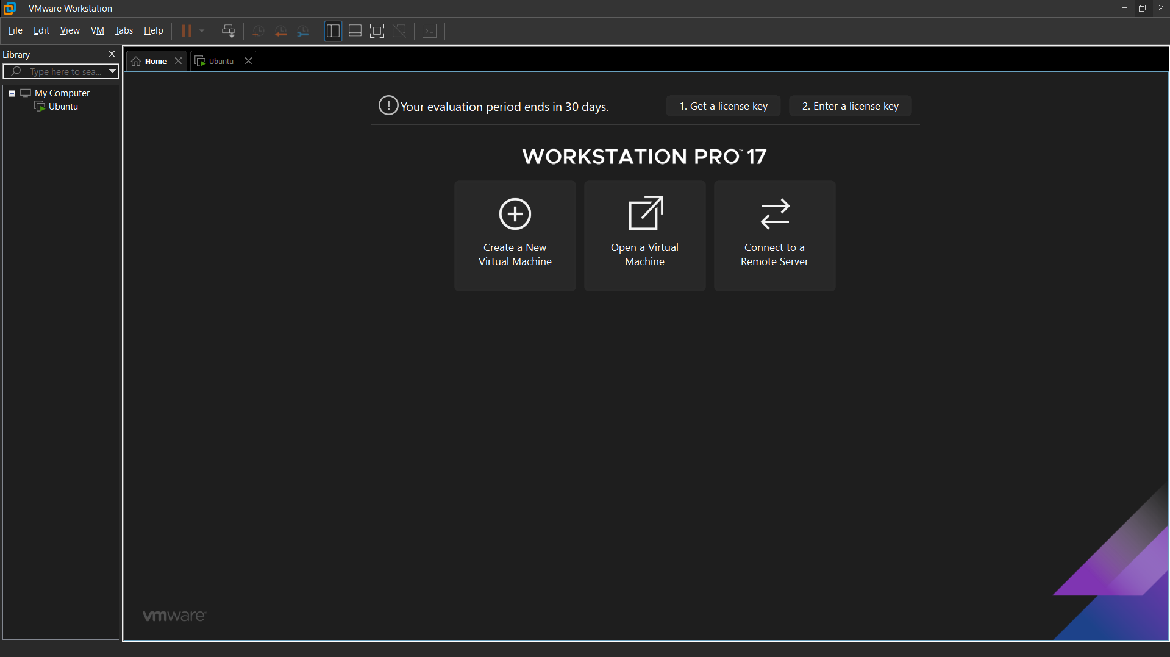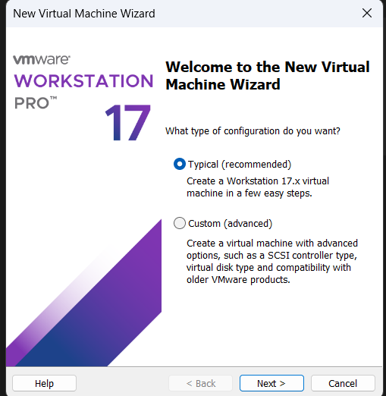

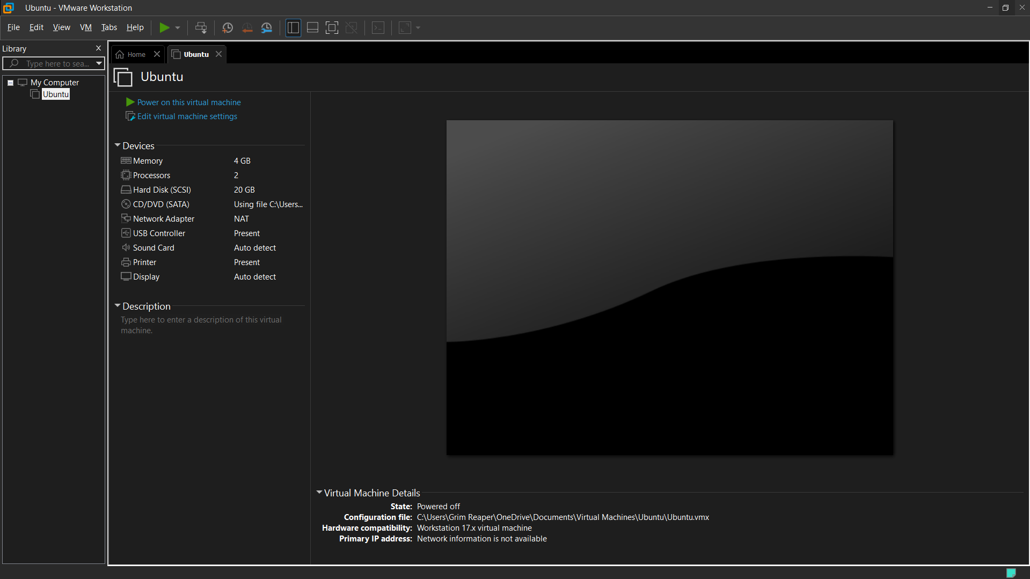
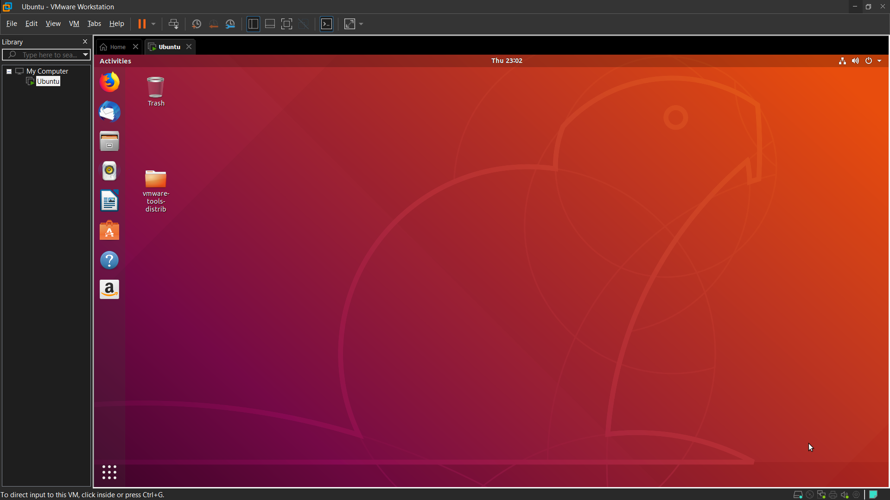

RESULT: Successfully Demonstrated the virtualization by installing type-2 hypervisor in your device, create and configure vm image with a host operating system.

